

MINISTRY OF EDUCATION

AND TRAINING

FPT UNIVERSITY

CAPSTONE PROJECT DOCUMENT

HEALTH PLUS

Report #2 – Project Plan

|  |  |
| --- | --- |
|  | HEALTH_PLUS |
| Group Member | Phạm Sĩ Thanh SE03430  Lê Đình Tuấn SE03342  Nguyễn Tiến Bình 00849  Lê Thành Tài SE03970 |
| Supervisor | Nguyễn Văn Sang |
| Project Code | HP_1 |

- Hanoi, 01/2017 -

## Project Organization

* + 1. **Software Process Model**

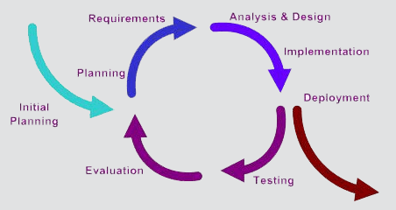

Figure 1- Iterative and Incremental Software Process Model

This figure above describes the information and products flow lifecycle process model. PRJ project uses the Iterative and Incremental Software Process Model.

#### Organization Structure

|  |  |
| --- | --- |
| No table of figures entries found. | **Responsibility** |
| Project Manager | Planning and defining scope, developing schedules, allocating resources, coordinating communication, generally responsible for keeping the team’s focus on main goal, and tries to keep the project team focused on the right goal at a time. |
| Technical Leader | Responsible for the underlying architecture for the software program, assigning tasks, mentoring people, reporting and updating progress of team member. |
| Business Analyst | Eliciting requirement, analyzing and documenting requirements, communicate requirements, identifying solution and verifying solution meets the requirements, leads and coordinates use-case modeling. Outline the system’s functionality. |
| Test Leader | Responsible for test execution, including test set-up and test run, evaluation of test run and error recovery, defect logging and test results recording. |
| Developer | Understanding requirement, building application follow task assign by technical leader and solution unify between all team members and report process of work daily. |

*Table 2-1: Project Structure*

#### Project Team Member

|  |  |
| --- | --- |
| **Team Member** | **Role** |
| SangNV | Supervisor |
| TaiLT | Project Manager, Developer |
| BinhNT | Technical Leader, Developer |
| ThanhPS | Quality Assurance Manager, Developer |
| TuanLD | Test Leader |

*Table 2-2: Project Team Member*

#### Project techniques, tools and infrastructures.

* Programming languages: C#, HTML, CSS, JavaScript.
* Software Architecture: MVC 5.
* Process Model: Iterative and Incremental Software Process Model.
* Version Control: Team Foundation Server (TFS).
* IDEs: Visual Studio 2015.
* DBMS: Microsoft SQL Server 2014.
* Web Server: IIS 7.
* Other:
* ProjectPlan365.
* Microsoft Office 2016.
* Microsoft Visio 2016.
* Microsoft Project 2016.
* ERD Plus
* Hardware:
* Personal computer for developing and testing with the minimum configuration: 4GB RAM, 80GB of hard disk, Intel core i5.
* Internet network connection with minimum speed 512kbit/s.
* A server computer for testing with the configuration: PC, Laptop Asus GL552, Hard drive SSD: 1 TB.

#### Meeting schedule.

* Meeting with supervisor: We have meeting with supervisor weekly at 9:00 AM Tuesday. In the meeting, we report about what we have done in last week, raise issue, problem to supervisor and receive adviser, solution to resolve issue, problem from supervisor.
* Meeting with all team member (face to face): Weekly meeting with all team member at 9:00 AM Friday. In the meeting, we report about what we have done in last working day, discuss about problem and give idea to resolve it.
* Meeting with all team member (calling via Skype): Daily meeting with team member via Skype, report about last working day and report what wills we do today.

#### Task sheet: Assignments and Timetable

Refer to



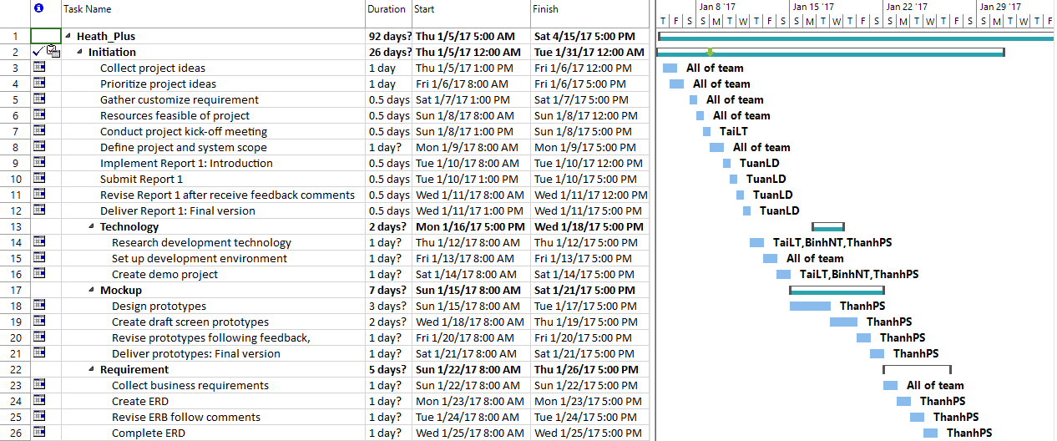

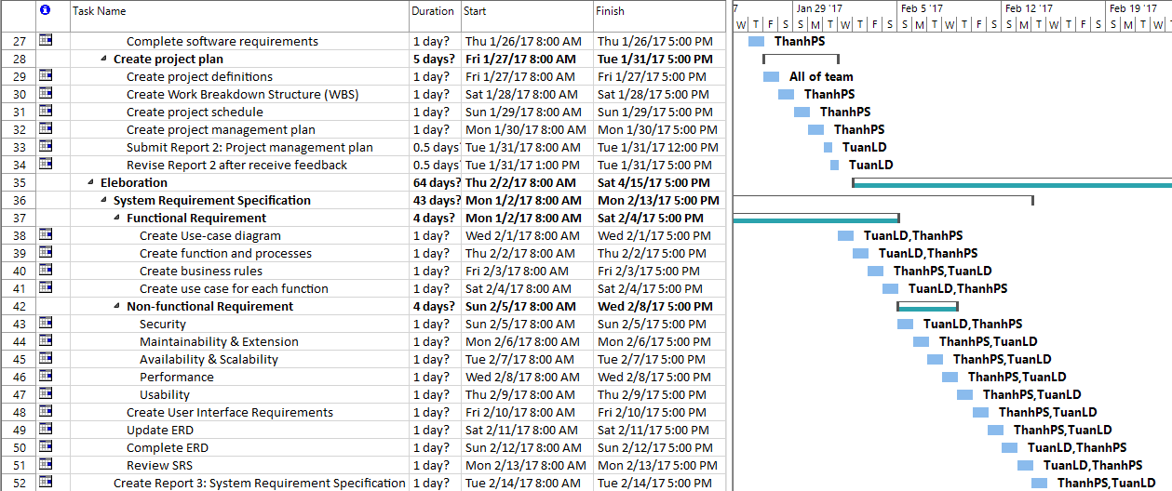

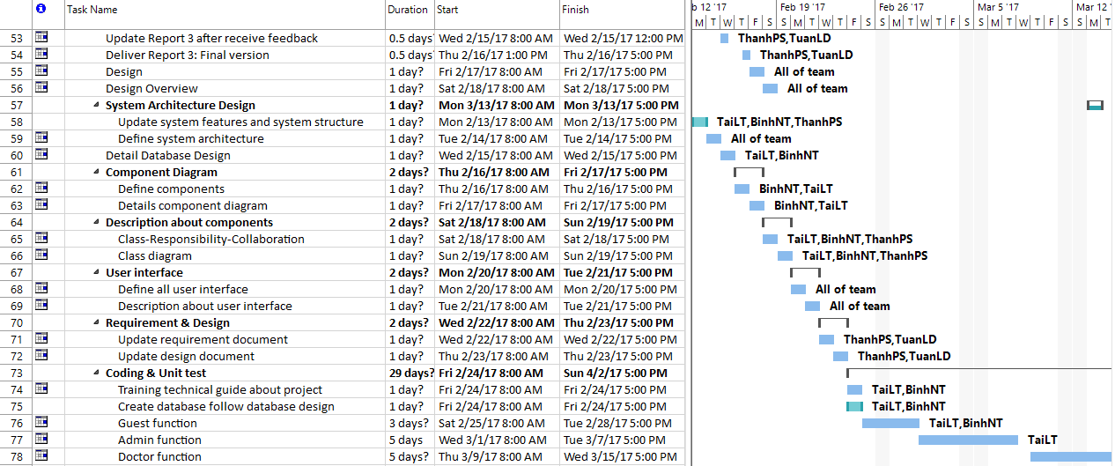

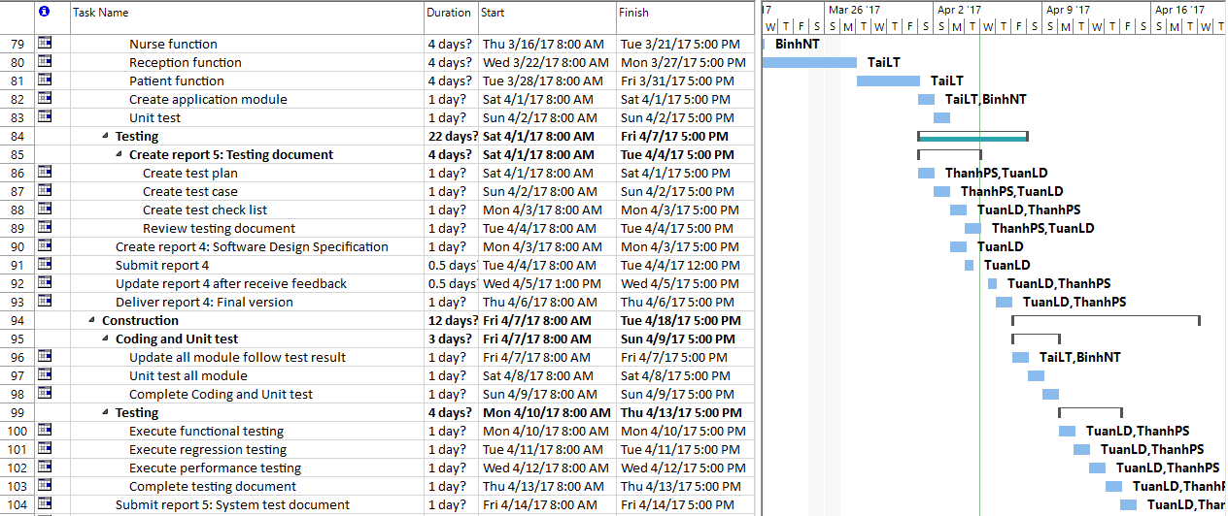

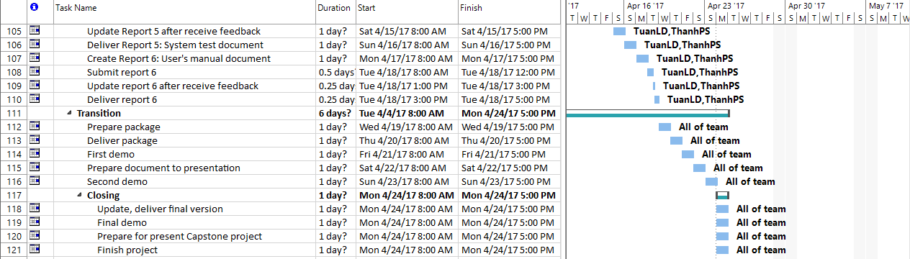

Figure 2 – Work break-down structure

#### Meeting minutes

All meeting minutes will be written follow this template:

| ***Meeting/Project Name:*** | *Health Plus.* | | | | |
| --- | --- | --- | --- | --- | --- |
| ***Date of Meeting:*** | *12/01/2017* | | ***Time: (Type)*** | *3 hours (Library)* | |
| ***Meeting Called By:*** | *Group Facebook, Skype* | | ***Location:*** | *FPT University‘s Library* | |
| ***Note Taker:*** | *All team* | | ***Time Keeper:*** | *All team* | |
| 1. Meeting Objective: | | | | | |
| Discuss all functions of systems. | | | | | |
| 2. Attendance | | | | | |
| ***Name*** | ***Roles*** | ***E-mail*** | | | ***Phone*** |
| TaiLT | Project Manager | tailtse03970@fpt.edu.vn | | |  |
| BinhNT | Technical Leader | binhnt00849@fpt.edu.vn | | |  |
| ThanhPS | Business Analyst | thanhpsse03430@fpt.edu.vn | | |  |
| TuanLD | Test Leader | tuanldse03342@fpt.edu.vn | | |  |
| 3. Content: | | | | | |
|  | | | | | |

#### Risk management

This part shows the risks that can occur during the project:

|  |  |  |  |  |  |
| --- | --- | --- | --- | --- | --- |
| **No.** | **Risks** | **Probability** | **Prevention** | **Correction** | **Impact** |
| 1 | Miscommunication | Medium | After a meeting, creating a meeting minutes. Every participant of the meeting should get a copy of it. Team member should not hesitate to ask and re-ask questions if things are not clear. | When it becomes clear that miscommunication is causing problems, the team members involved and the customer are gathered in a meeting to clear things up. | High |
| 2 | Time shortage | High | Care is taken to plan enough spare time | When tasks fail to be finished in time or when they are finished earlier than planned the project planning is adjusted. | High |
| 3 | Design error | Medium | The design should be reviewed very critically. The supervisor should be consulted frequently on his opinion about the feasibility and the correctness of certain design decisions. | When errors in the design are noticed the supervisor should be consulted to help correct the design errors as soon as possible. Also all the work, that depends on the faulty design, should be halted until the error is corrected. | High |
| 4 | Illness or absence of team member | High | Team members should warn PM timely before a planned period of absence. | By ensuring that knowledge is shared between team members, work can be taken over quickly by someone else if a person gets ill. | Medium |
| 5 | Unavailability of the technical supervisor when needed | Medium | Meetings with the technical supervisor can be planned in advance and time has been reserved in his schedule for counseling the team. | A different appointment is made, or another expert is consulted. | Medium |